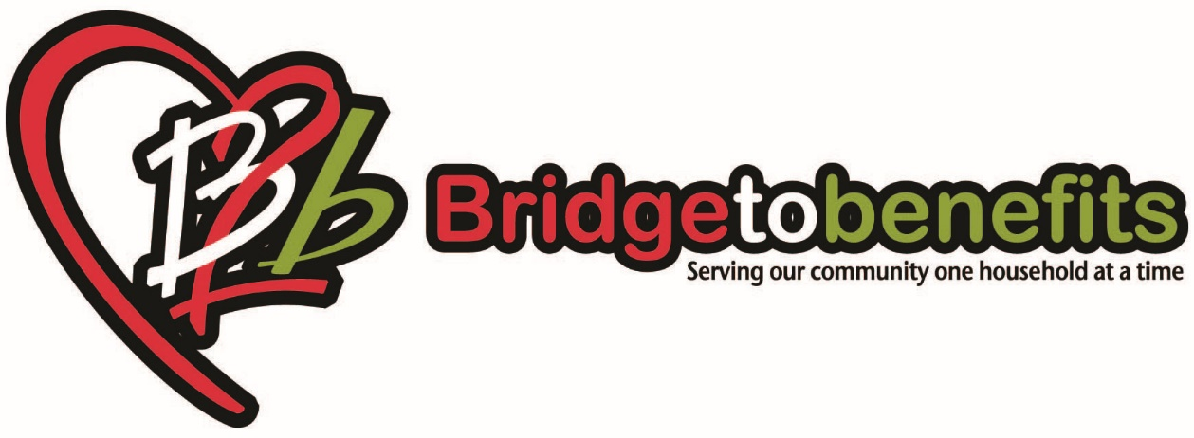

In order to process your application, we will need to make copies of all the following documents. Your application will be deemed incomplete if any information is missing. Once all information has been attained, we will begin to evaluate your application.

- An eviction notice from your landlord or shut-off notice from your utility company.
- A ledger from your landlord or a recent utility bill.
- Identification for everyone who lives in the household e.g. State ID, Birth Certificates of DPA printouts.
- Proof of all sources of income for everyone in the household, which includes SSI, unemployment and child support.

Please sign and date that you understand your application, and it will not be processed until all information has been given, and that emergency funding is not guaranteed.

Client signature and date: ________________________________________________________

Case Manager and date: __________________________________________________________

